* In this lecture, we are going to follow a series of steps:
* First we picked a switch from the bottom toolbox.
* Then we took 2 computers from it.
* Then we connected the two computers to the switch using a wire called “copper straight”.
* Then we assigned IP to the two computers.
* Then we sent a packet from first computer to the second computer.
* By seeing simulation which shows successful we analyze that devices connected to the same switch can communicate with each other.
* So by opening the Switch CLI and by typing “show vlan” in the privilege mode we come to know that we have 24 ports all in default.It means we have 24 ports in our default Vlan.

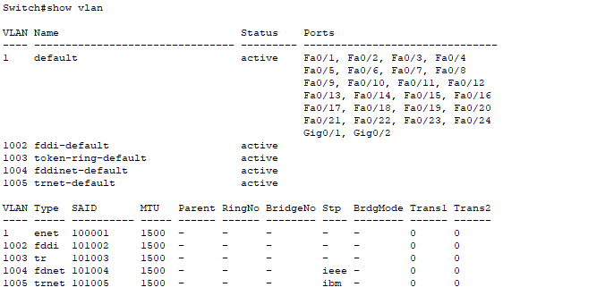

* I just want to take any number eg: 2 of these ports to create another vlan.In this case I am going to make two vlans such as Office1 and office2
* So we have seen the information using “show vlan”
* After this we assign an id of vlan and then assign a name to that vlan
* For vlan 1 (office 1)
  + Id = vlan 10
  + Name =name Office1
* For vlan 2 (office 2)
  + Id = vlan 20
  + Name =name Office2

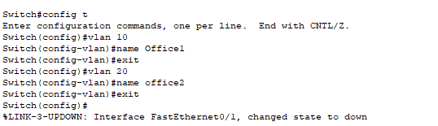

* Now connect 2 pc with office1 vlan and the third one to the vlan of office2
* Remember that computers connected to the same vlan can communicate with each other.
* So by hovering over the copper straight we can determine the fa of it.
* So lets assume first computer has fa 0/2

vlan fa 0/2

switchport mode access

switchport access vlan 10

Similarly for second computer

vlan fa 0/3

switchport mode access

switchport access vlan 10

Be careful about the id when connecting the third computer

vlan fa 0/4

switchport mode access

switchport access vlan 20

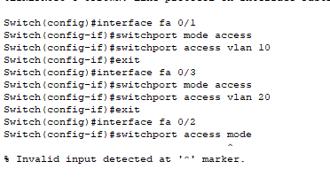

So now when you will transfer packet from first computer to second computer it will be successful but when you will ping it to third computer there will be a failure since it’s a different vlan.

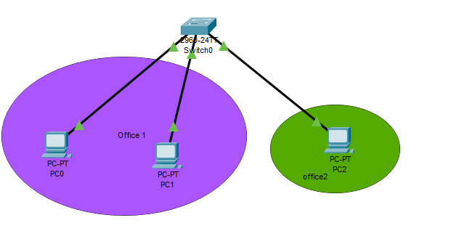



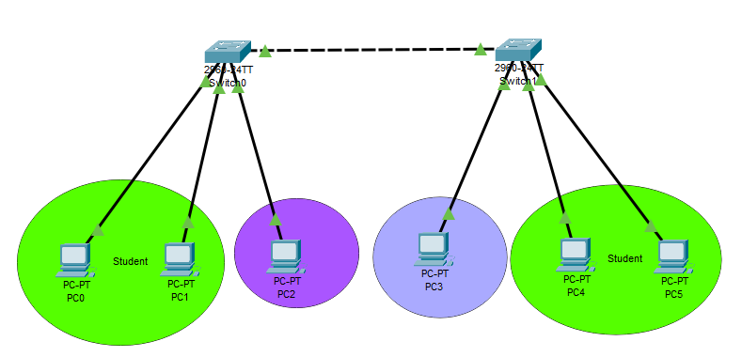

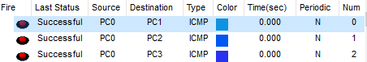

All sending across 2 routers before doing anything is successful.Our am is to restrict this using vlan creation.

**SWITCH # 01**

**Show vlan**

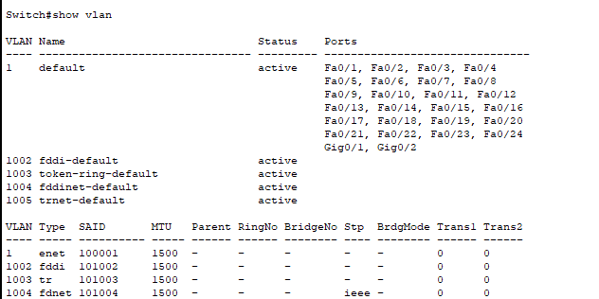

**Creating names and ids**

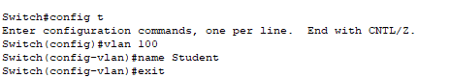



**Assigning vlan to devices**

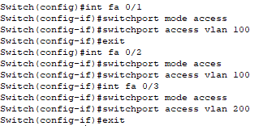

**Any packet sent from student to teacher in switch # 01 will give this**

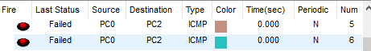

**SWITCH # 02**

**Show vlan**

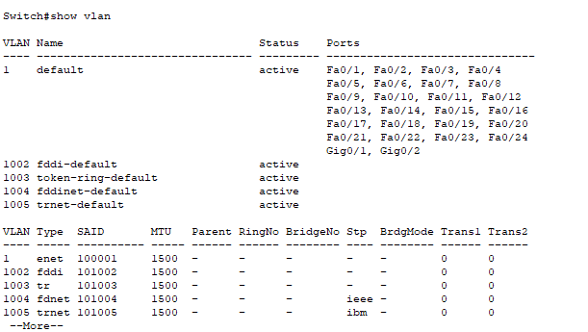

**Setting ids and names**

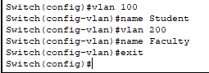

**Assigning vlan to devices**

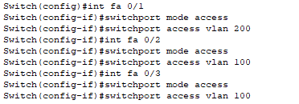

**Any packet sent from student to teacher in switch # 01 will give this**

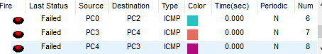

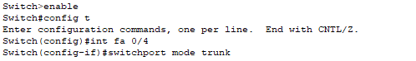

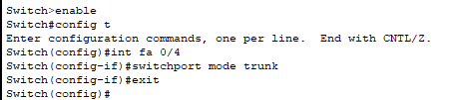

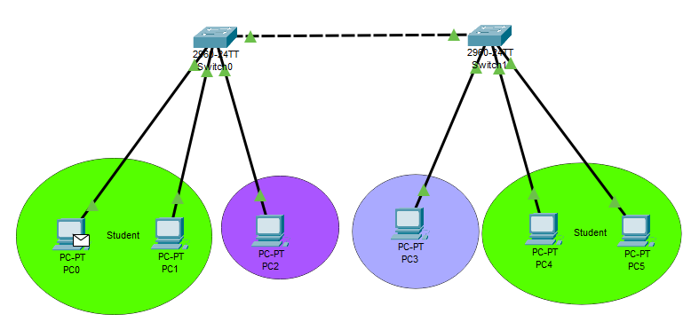

**When I sent a packet from the student of first switch to the student of the second switch that will lead to successful otput**

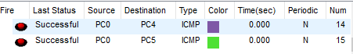

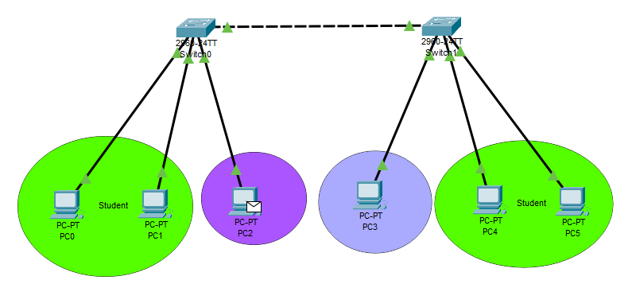

**From faculty of one switch to the faculty of the next switch**

